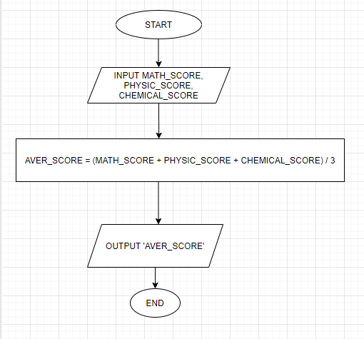

*BEGIN*

*INPUT 'MATH SCORE', 'PHYSIC SCORE', 'CHEMICAL SCORE'*

*AVERAGE SCORE = (MATH SCORE + PHYSIC SCORE + CHEMICAL SCORE) / 3*

*PRINT 'AVERAGE SCORE'*

*END*